MODULE 1

Q1.Read from STDIN, write to STDOUT
#include <stdio.h>
int main() {
int n;
char s[16]; // String length is at most 15 + 1 for null terminator
// Read the integer N and string S
if (scanf("%d %s", &n, s) == 2) {
// Output N * 2 on the first line
printf("%d\n", n * 2);
// Output the string S on the second line
printf("%s\n", s);
}
return 0;
}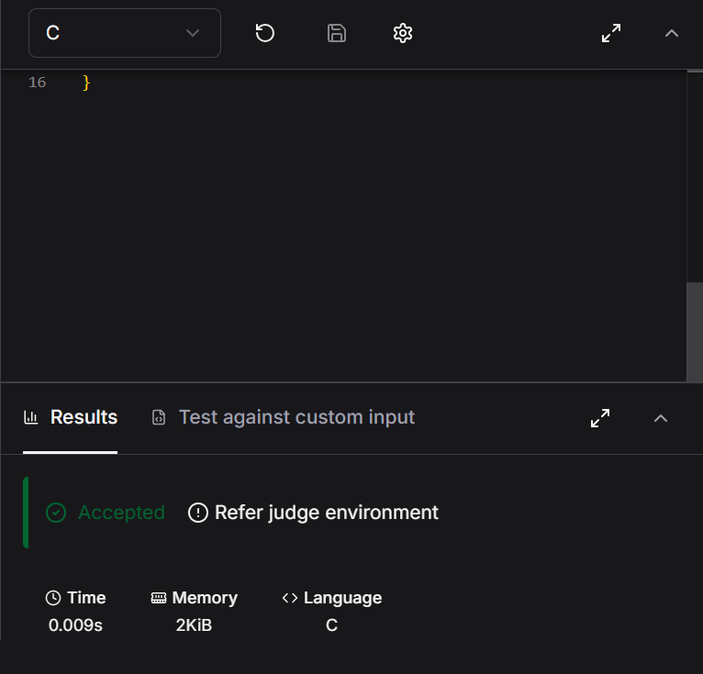

Q2.Solve Me first
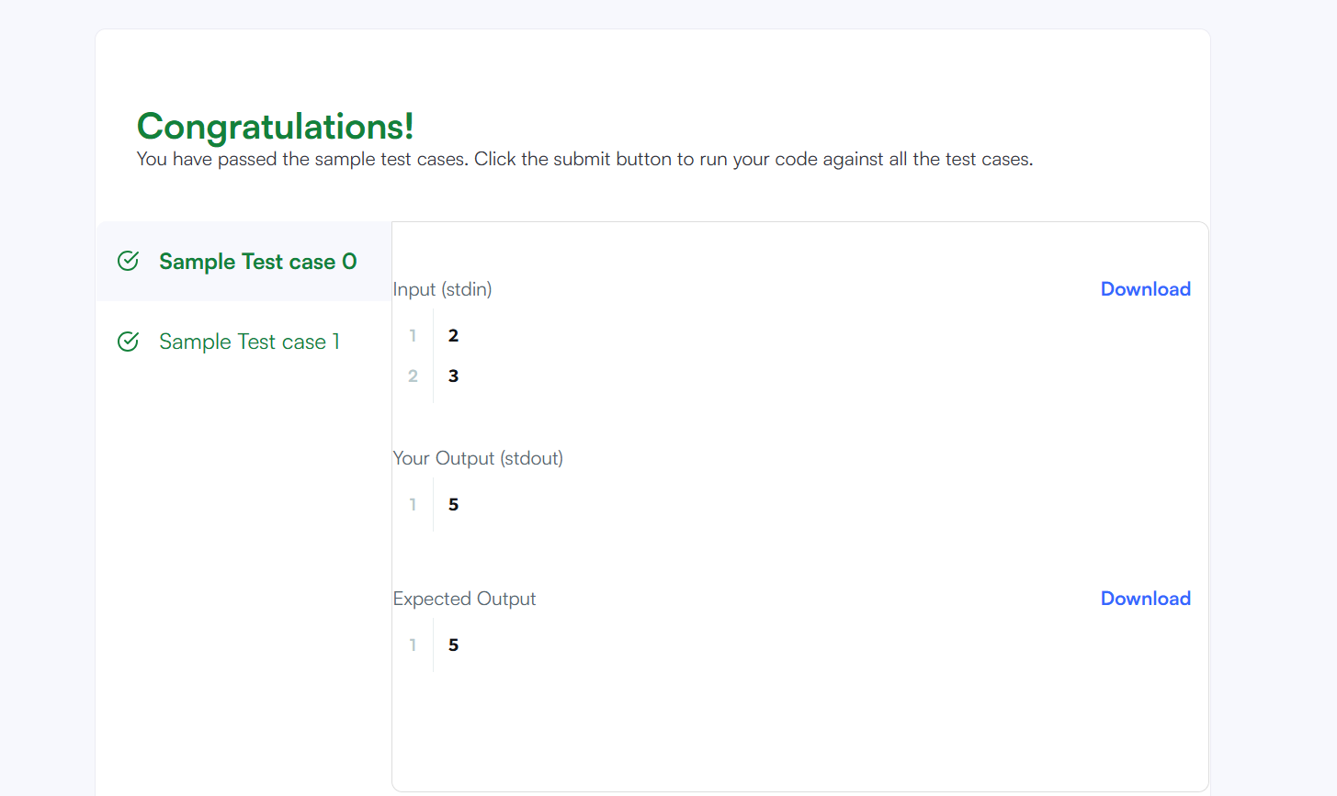
#include <stdio.h>
#include <string.h>
#include <math.h>
#include <stdlib.h>

int solveMeFirst(int a, int b) {
// Hint: Type return a+b; below
return a+b;
}

int main() {
int num1,num2;
scanf("%d %d",&num1,&num2);
int sum;
sum = solveMeFirst(num1,num2);
printf("%d",sum);
return 0;}

3. 2235 – Add Two Integers
#CODE
int sum(int num1, int num2) {
return(num1+num2);
}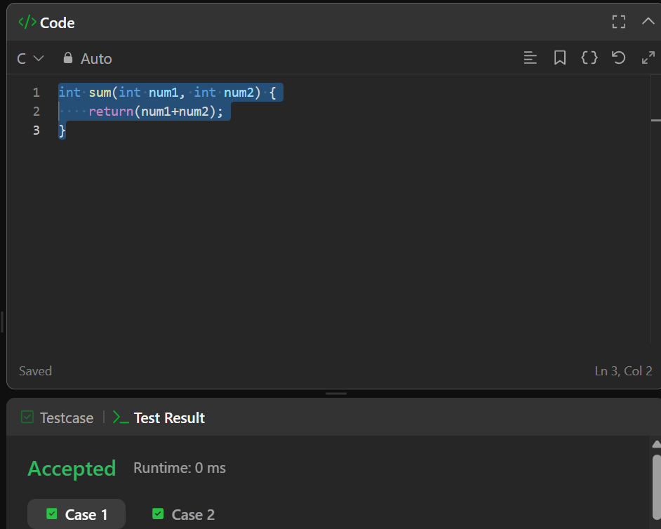

4. 2651 – Add two Integers
#CODE
int findDelayedArrivalTime(int arrivalTime, int delayedTime) {
return (arrivalTime + delayedTime) % 24;
}

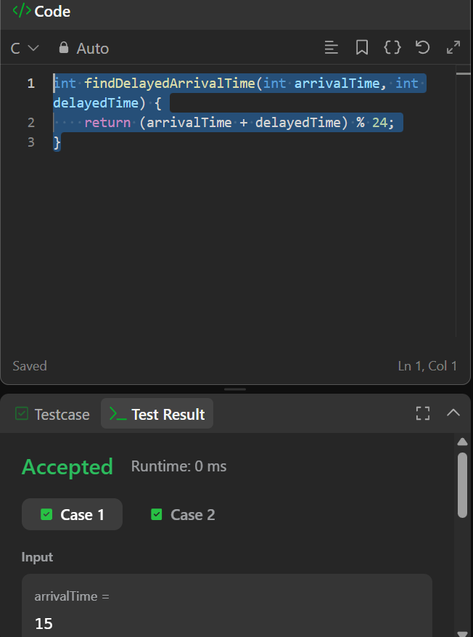

5. 2739 - Total Distance Traveled
#CODE
int distanceTraveled(int mainTank, int additionalTank) {
int totalFuelUsed = 0;
while (mainTank >= 5) {
// Spend 5 liters of fuel from the main tank
totalFuelUsed += 5;
mainTank -= 5;
// Inject 1 liter from the additional tank if available
if (additionalTank > 0) {
additionalTank--;
mainTank++;
}
}
totalFuelUsed += mainTank;
return totalFuelUsed * 10;}
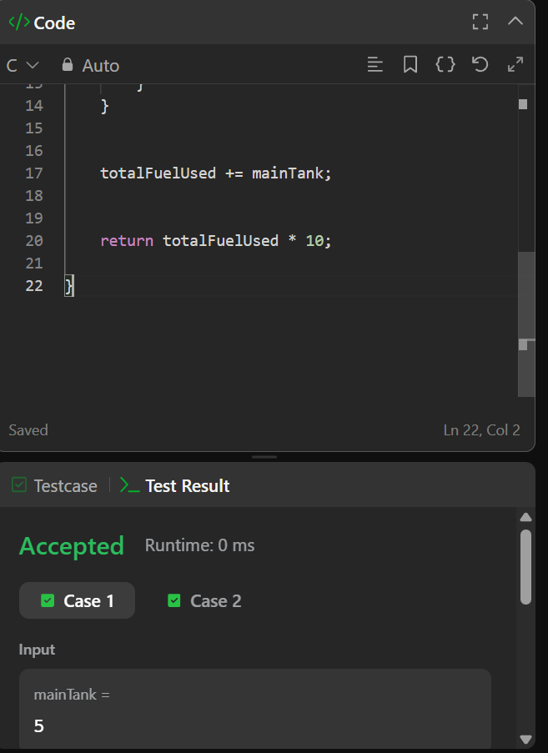

MODULE 2

Conditional Statements in C
#CODE
#include <assert.h>
#include <limits.h>
#include <math.h>
#include <stdbool.h>
#include <stddef.h>
#include <stdint.h>
#include <stdio.h>
#include <stdlib.h>
#include <string.h>

char* readline();

int main()
{
char* n_endptr;
char* n_str = readline();
int n = strtol(n_str, &n_endptr, 10);

if (n_endptr == n_str || *n_endptr != '\0') { exit(EXIT_FAILURE); }

// Write Your Code Here
if (n == 1) {
printf("one\n");
} else if (n == 2) {
printf("two\n");
} else if (n == 3) {
printf("three\n");
} else if (n == 4) {
printf("four\n");
} else if (n == 5) {
printf("five\n");
} else if (n == 6) {
printf("six\n");
} else if (n == 7) {
printf("seven\n");
} else if (n == 8) {
printf("eight\n");
} else if (n == 9) {
printf("nine\n");
} else {
printf("Greater than 9\n");
}

return 0;
return 0;
}

char* readline() {
size_t alloc_length = 1024;
size_t data_length = 0;
char* data = malloc(alloc_length);

while (true) {
char* cursor = data + data_length;
char* line = fgets(cursor, alloc_length - data_length, stdin);

if (!line) { break; }

data_length += strlen(cursor);

if (data_length < alloc_length - 1 || data[data_length - 1] == '\n') { break; }

size_t new_length = alloc_length << 1;
data = realloc(data, new_length);

if (!data) { break; }

alloc_length = new_length;
}

if (data[data_length - 1] == '\n') {
data[data_length - 1] = '\0';
}
data = realloc(data, data_length);
return data;
}

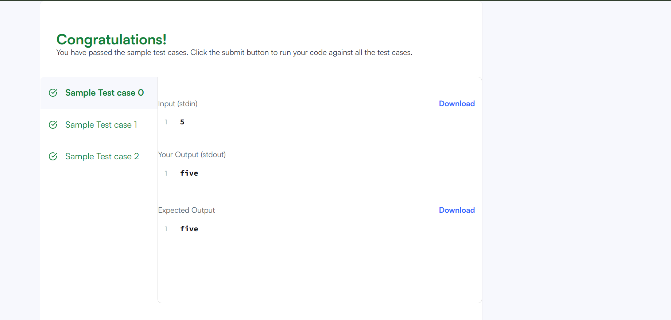

2413 – Smallest Even Multiple
#CODE
int smallestEvenMultiple(int n) {
if((n%2)==0){
return n;
}
else if((n%2)!= 0){
return (n*2);
}
return 0;
}
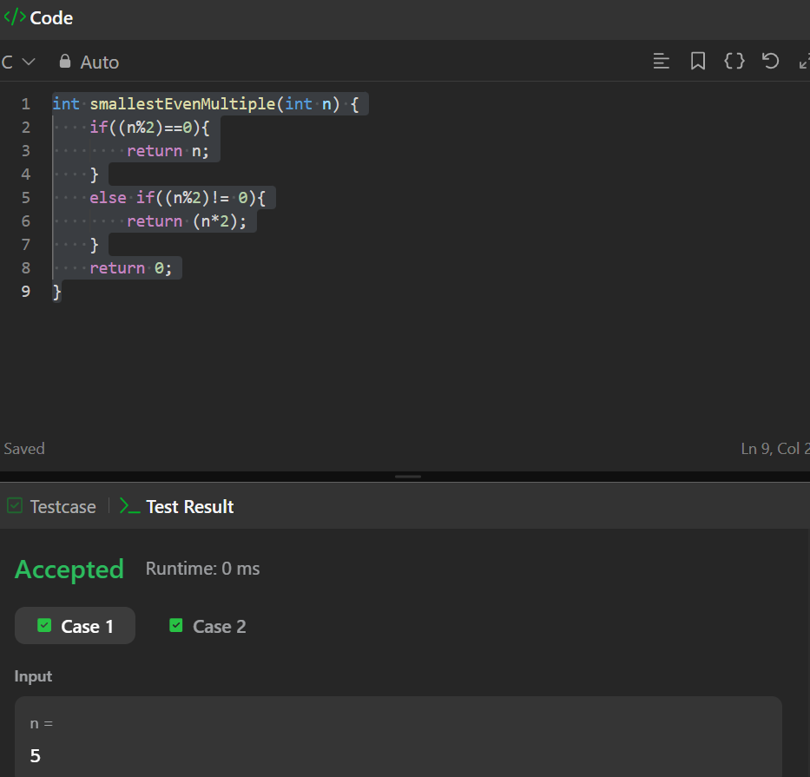

Grading Students
#CODE
#include <assert.h>
#include <ctype.h>
#include <limits.h>
#include <math.h>
#include <stdbool.h>
#include <stddef.h>
#include <stdint.h>
#include <stdio.h>
#include <stdlib.h>
#include <string.h>

char* readline();
char* ltrim(char*);
char* rtrim(char*);

int parse_int(char*);

/*
* Complete the 'gradingStudents' function below.
*
* The function is expected to return an INTEGER_ARRAY.
* The function accepts INTEGER_ARRAY grades as parameter.
*/

/*
* To return the integer array from the function, you should:
* - Store the size of the array to be returned in the result_count variable
* - Allocate the array statically or dynamically
*
* For example,
* int* return_integer_array_using_static_allocation(int* result_count) {
* *result_count = 5;
*
* static int a[5] = {1, 2, 3, 4, 5};
*
* return a;
* }
*
* int* return_integer_array_using_dynamic_allocation(int* result_count) {
* *result_count = 5;
*
* int *a = malloc(5 * sizeof(int));
*
* for (int i = 0; i < 5; i++) {
* *(a + i) = i + 1;
* }
*
* return a;
* }
*
*/
int* gradingStudents(int grades_count, int* grades, int* result_count) {
*result_count = grades_count;
int* result = malloc(grades_count * sizeof(int));

for (int i = 0; i < grades_count; i++) {
int grade = grades[i];
if (grade >= 38) {
int remainder = grade % 5;
if (remainder >= 3) {
grade += (5 - remainder);
}
}
result[i] = grade;
}

return result;
}

int main()
{
FILE* fptr = fopen(getenv("OUTPUT_PATH"), "w");

int grades_count = parse_int(ltrim(rtrim(readline())));

int* grades = malloc(grades_count * sizeof(int));

for (int i = 0; i < grades_count; i++) {
int grades_item = parse_int(ltrim(rtrim(readline())));

*(grades + i) = grades_item;
}

int result_count;
int* result = gradingStudents(grades_count, grades, &result_count);

for (int i = 0; i < result_count; i++) {
fprintf(fptr, "%d", *(result + i));

if (i != result_count - 1) {
fprintf(fptr, "\n");
}
}

fprintf(fptr, "\n");

fclose(fptr);

return 0;
}

char* readline() {
size_t alloc_length = 1024;
size_t data_length = 0;

char* data = malloc(alloc_length);

while (true) {
char* cursor = data + data_length;
char* line = fgets(cursor, alloc_length - data_length, stdin);

if (!line) {
break;
}

data_length += strlen(cursor);

if (data_length < alloc_length - 1 || data[data_length - 1] == '\n') {
break;
}

alloc_length <<= 1;

data = realloc(data, alloc_length);

if (!data) {
data = '\0';

break;
}
}

if (data[data_length - 1] == '\n') {
data[data_length - 1] = '\0';

data = realloc(data, data_length);

if (!data) {
data = '\0';
}
} else {
data = realloc(data, data_length + 1);

if (!data) {
data = '\0';
} else {
data[data_length] = '\0';
}
}

return data;
}

char* ltrim(char* str) {
if (!str) {
return '\0';
}

if (!*str) {
return str;
}

while (*str != '\0' && isspace(*str)) {
str++;
}

return str;
}

char* rtrim(char* str) {
if (!str) {
return '\0';
}

if (!*str) {
return str;
}

char* end = str + strlen(str) - 1;

while (end >= str && isspace(*end)) {
end--;
}

*(end + 1) = '\0';

return str;
}

int parse_int(char* str) {
char* endptr;
int value = strtol(str, &endptr, 10);

if (endptr == str || *endptr != '\0') {
exit(EXIT_FAILURE);
}

return value;
}

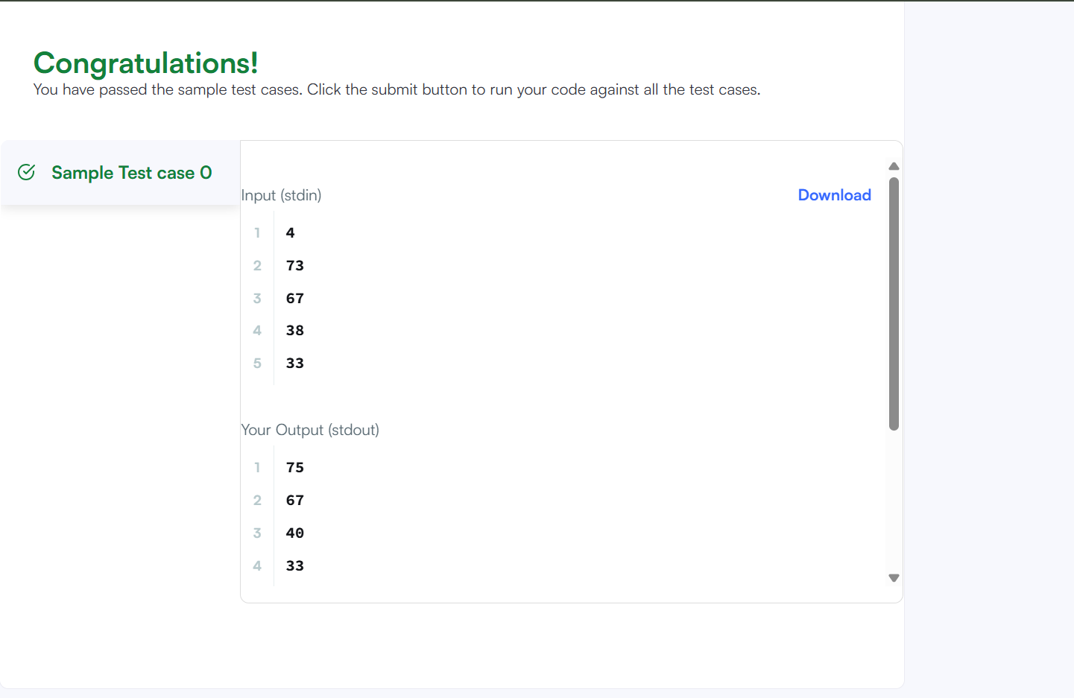

Roy and Profile Picture
#CODE
#include <stdio.h>

int main() {
int L, N;
scanf("%d", &L);
scanf("%d", &N);
for (int i = 0; i < N; i++) {
int W, H;
scanf("%d %d", &W, &H);
if (W < L || H < L) {
printf("UPLOAD ANOTHER\n");
} else if (W == H) {
printf("ACCEPTED\n");
} else {
printf("CROP IT\n");
}} return 0;}
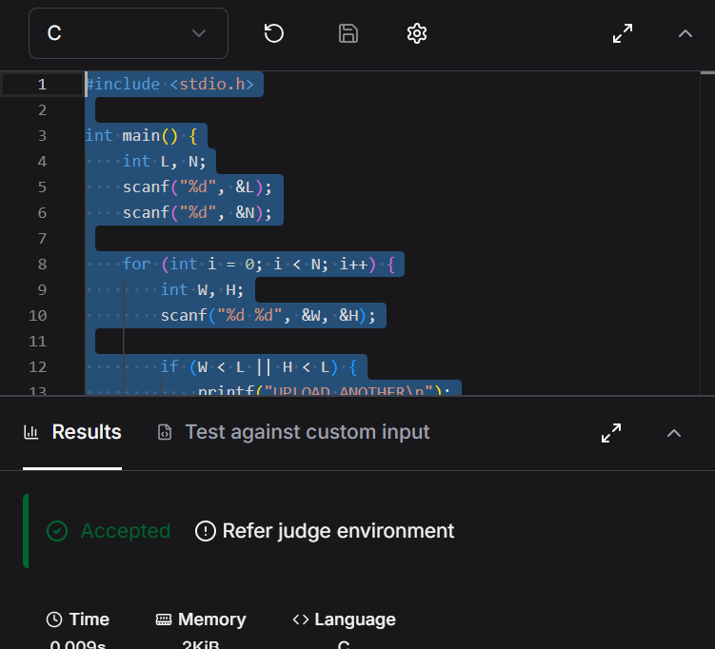

FizzBuzz
#CODE
#include <stdio.h>
int main() {
for (int i = 1; i <= 100; i++) {
if (i % 15 == 0) printf("FizzBuzz\n");
else if (i % 3 == 0) printf("Fizz\n");
else if (i % 5 == 0) printf("Buzz\n");
else printf("%d\n", i);
}
return 0;}


MODULE 3

1. For Loop in C
#include <stdio.h>
#include <string.h>
#include <math.h>
#include <stdlib.h>
int main()
{int a, b;
scanf("%d\n%d", &a, &b);
char *words[] = {"one", "two", "three", "four", "five", "six", "seven", "eight", "nine"};
for (int i = a; i <= b; i++) {
if (i >= 1 && i <= 9) {
printf("%s\n", words[i - 1]);
} else if (i % 2 == 0) {
printf("even\n");
} else {
printf("odd\n");}} return 0;}
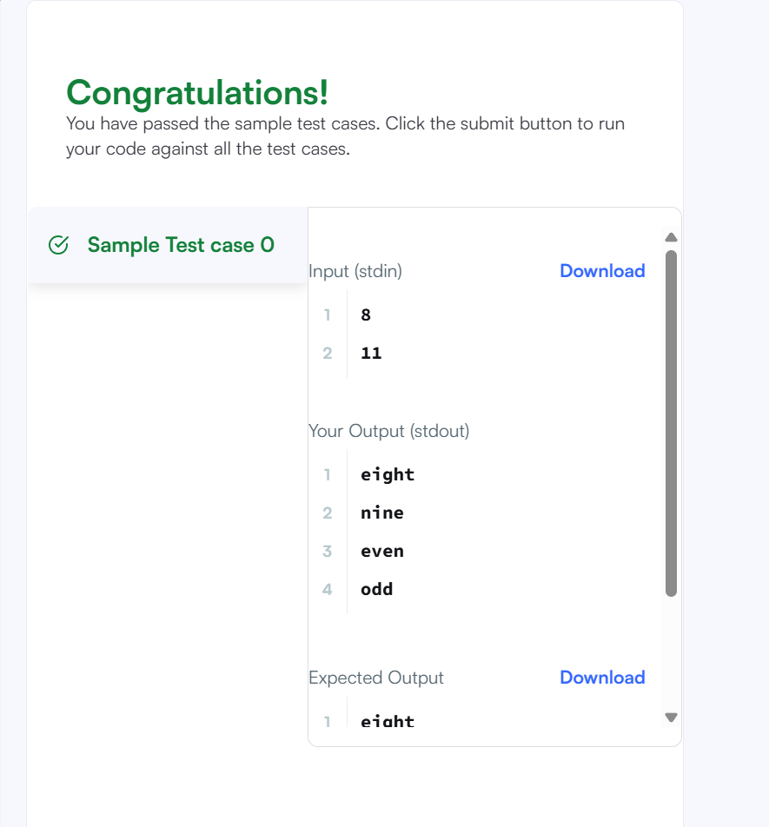

2. 1342 — Number of Steps to Reduce a Number to Zero
#CODE
int numberOfSteps(int num) {
int count = 0;
while(num>0){
if(num%2 ==0){
num/=2; }
else{
num -= 1;}
count +=1;
}return count;
}
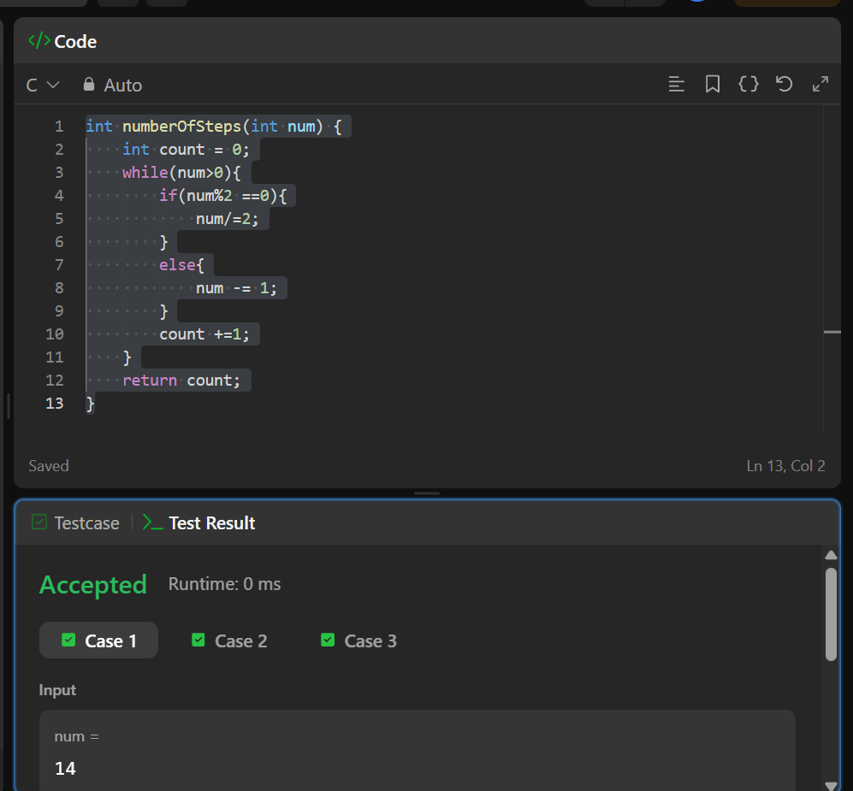

3. 2169 - Number of Steps to Reduce a Number to Zero
#CODE
int countOperations(int num1, int num2) {
int count = 0;
while(num1>0 && num2>0){
if(num1>=num2){
num1 = num1-num2;
}
else if(num2>=num1){
num2=num2-num1;
}
count += 1;
}
return count;
}
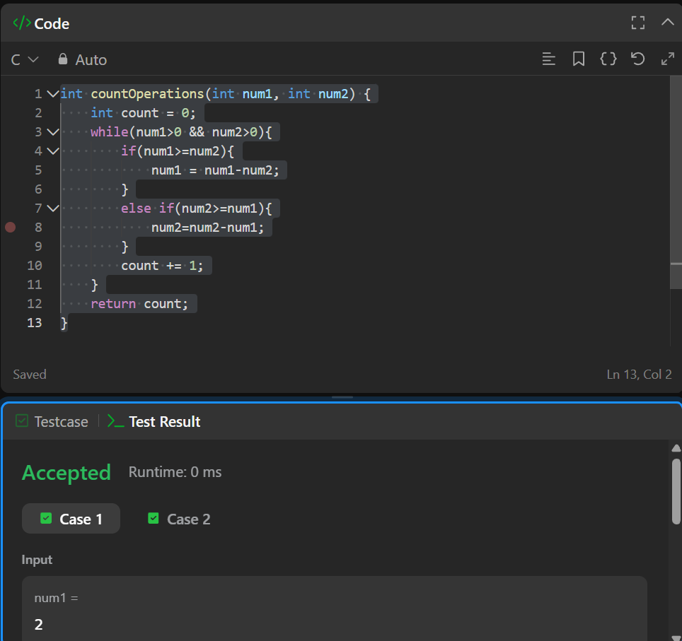

4. 1523 — Count Odd Numbers in an Interval Range
#CODE

int countOdds(int low, int high){
return (high + 1) / 2 - low / 2;
}
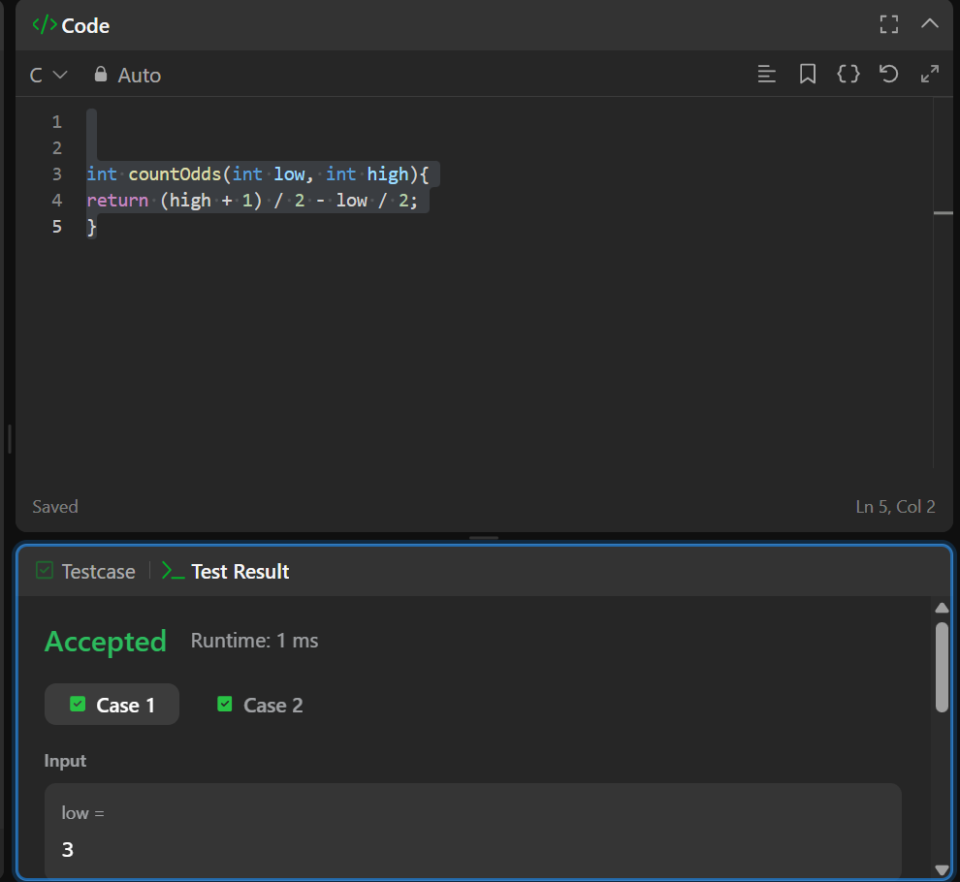

5. 2652 — Sum Multiples
int sumOfMultiples(int n) {
int total_sum = 0;

for (int i = 1; i <= n; i++) {
if (i % 3 == 0 || i % 5 == 0 || i % 7 == 0) {
total_sum += i;
}
}

return total_sum;
}
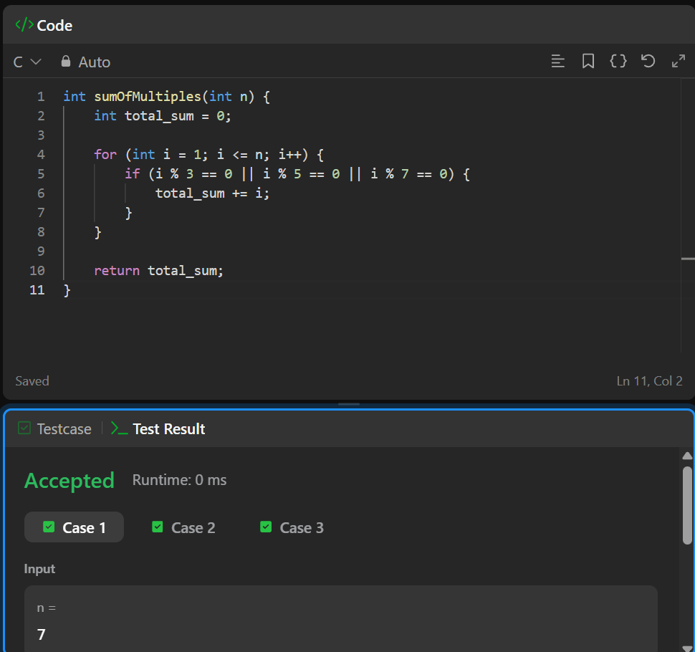

6. Number Line Jumps
#include <assert.h>
#include <ctype.h>
#include <limits.h>
#include <math.h>
#include <stdbool.h>
#include <stddef.h>
#include <stdint.h>
#include <stdio.h>
#include <stdlib.h>
#include <string.h>

char* readline();
char* ltrim(char*);
char* rtrim(char*);
char** split_string(char*);

int parse_int(char*);

/*
* Complete the 'kangaroo' function below.
*
* The function is expected to return a STRING.
* The function accepts following parameters:
* 1. INTEGER x1
* 2. INTEGER v1
* 3. INTEGER x2
* 4. INTEGER v2
*/

/*
* To return the string from the function, you should either do static allocation or dynamic allocation
*
* For example,
* char* return_string_using_static_allocation() {
* static char s[] = "static allocation of string";
*
* return s;
* }
*
* char* return_string_using_dynamic_allocation() {
* char* s = malloc(100 * sizeof(char));
*
* s = "dynamic allocation of string";
*
* return s;
* }
*
*/
char* kangaroo(int x1, int v1, int x2, int v2) {
if (v1 > v2 && (x2 - x1) % (v1 - v2) == 0) {
return "YES";
}
return "NO";
}

int main()
{
FILE* fptr = fopen(getenv("OUTPUT_PATH"), "w");

char** first_multiple_input = split_string(rtrim(readline()));

int x1 = parse_int(*(first_multiple_input + 0));

int v1 = parse_int(*(first_multiple_input + 1));

int x2 = parse_int(*(first_multiple_input + 2));

int v2 = parse_int(*(first_multiple_input + 3));

char* result = kangaroo(x1, v1, x2, v2);

fprintf(fptr, "%s\n", result);

fclose(fptr);

return 0;
}

char* readline() {
size_t alloc_length = 1024;
size_t data_length = 0;

char* data = malloc(alloc_length);

while (true) {
char* cursor = data + data_length;
char* line = fgets(cursor, alloc_length - data_length, stdin);

if (!line) {
break;
}

data_length += strlen(cursor);

if (data_length < alloc_length - 1 || data[data_length - 1] == '\n') {
break;
}

alloc_length <<= 1;

data = realloc(data, alloc_length);

if (!data) {
data = '\0';

break;
}
}

if (data[data_length - 1] == '\n') {
data[data_length - 1] = '\0';

data = realloc(data, data_length);

if (!data) {
data = '\0';
}
} else {
data = realloc(data, data_length + 1);

if (!data) {
data = '\0';
} else {
data[data_length] = '\0';
}
}

return data;
}

char* ltrim(char* str) {
if (!str) {
return '\0';
}

if (!*str) {
return str;
}

while (*str != '\0' && isspace(*str)) {
str++;
}

return str;
}

char* rtrim(char* str) {
if (!str) {
return '\0';
}

if (!*str) {
return str;
}

char* end = str + strlen(str) - 1;

while (end >= str && isspace(*end)) {
end--;
}

*(end + 1) = '\0';

return str;
}

char** split_string(char* str) {
char** splits = NULL;
char* token = strtok(str, " ");

int spaces = 0;

while (token) {
splits = realloc(splits, sizeof(char*) * ++spaces);

if (!splits) {
return splits;
}

splits[spaces - 1] = token;

token = strtok(NULL, " ");
}

return splits;
}

int parse_int(char* str) {
char* endptr;
int value = strtol(str, &endptr, 10);

if (endptr == str || *endptr != '\0') {
exit(EXIT_FAILURE);
}

return value;
}

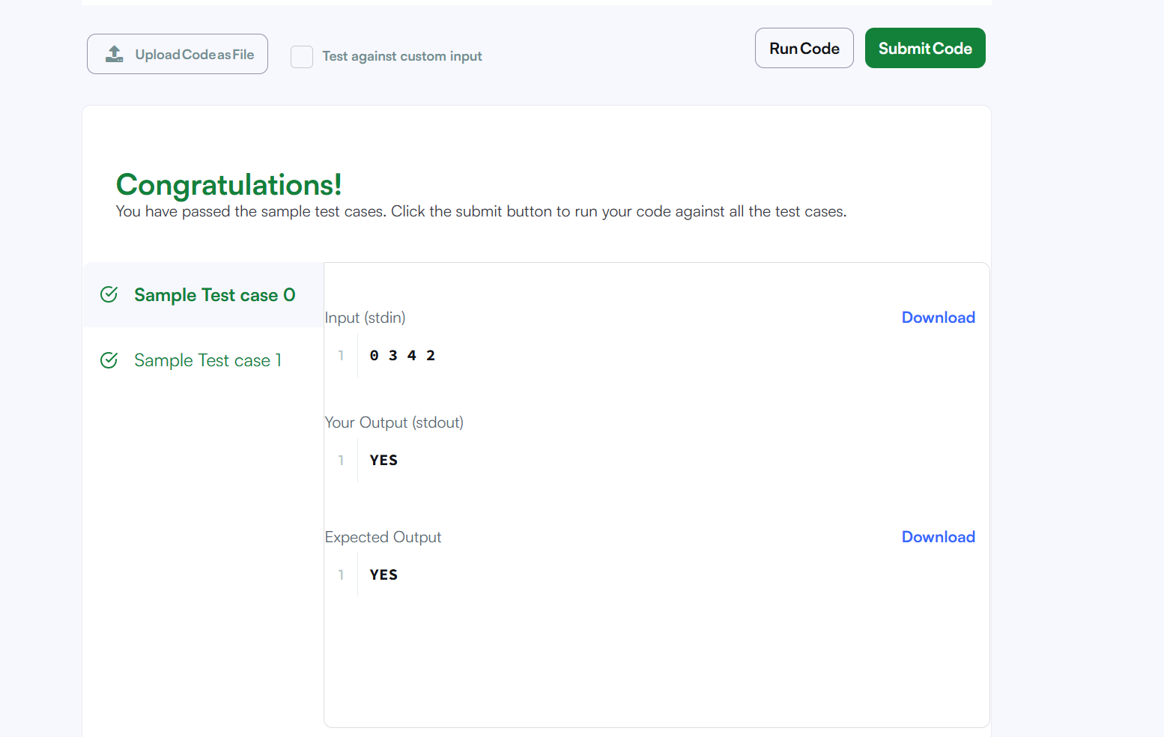

#Module 4

Q1. Digit Sum
#code
int main(){
int T, num, first, last;
scanf("%d", &T); // Reading number of test cases
while (T > 0) {
scanf("%d", &num); // Reading the number
last = num % 10; // Getting last digit
first = num;
while (first >= 10) {
first = first / 10; // Getting first digit
}
printf("%d\n", first + last); // Printing sum
T--;
}
return 0;
}

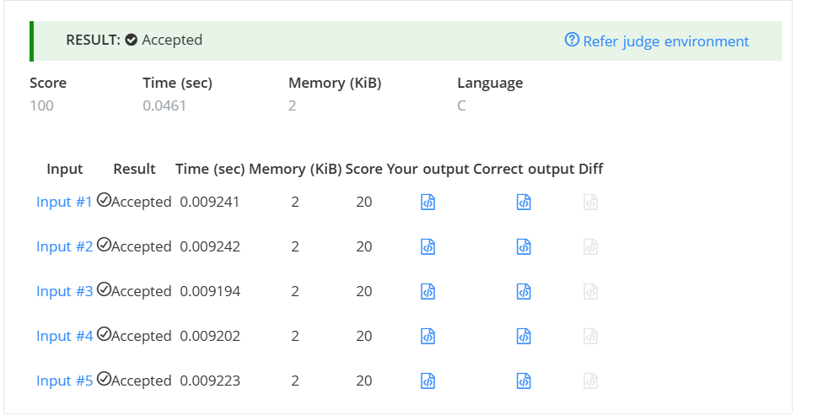

Q2. Find Digit
#Code
int temp, digit, count = 0;
temp = n;
while (temp > 0) {
digit = temp % 10;
if (digit != 0) {
if (n % digit == 0) {
count++;
}
}
temp = temp / 10;
}
return count;
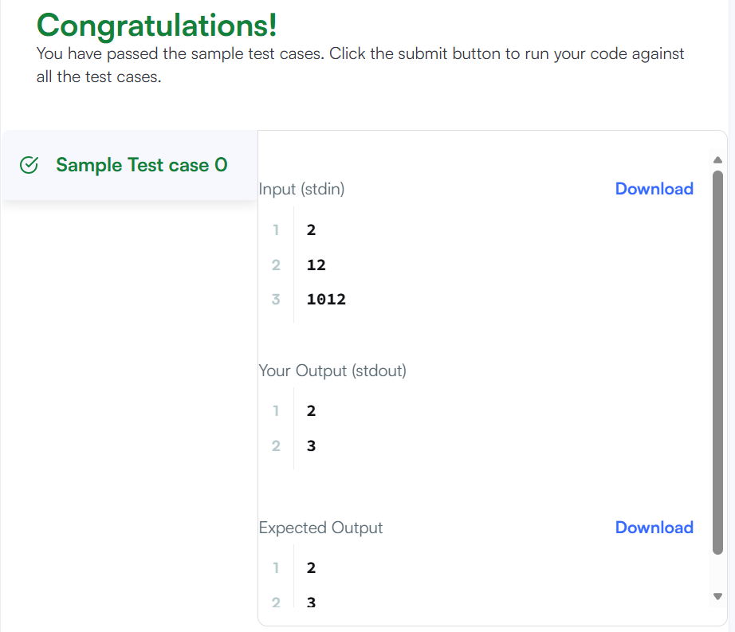

Q3. 1281 — Subtract the Product and Sum of Digits
#Code
class Solution {
public:
int subtractProductAndSum(int n) {
int sum = 0;
int product = 1;
int digit;
while (n > 0) {
digit = n % 10;
sum = sum + digit;
product = product * digit;
n = n / 10;
}
return product - sum;
}
};

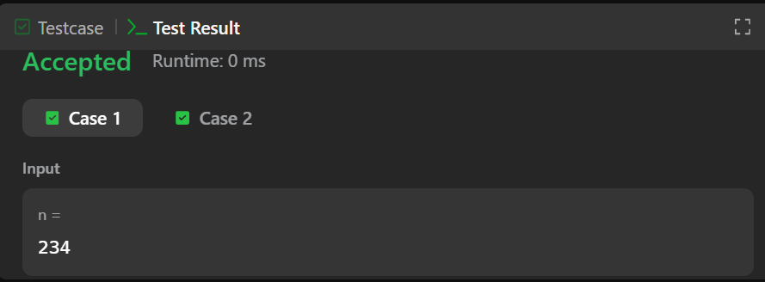

Q4.2520 — Count the Digits That Divide a Number
#code
class Solution {
public:
int countDigits(int num) {
int temp = num;
int digit;
int count = 0;
while (temp > 0) {
digit = temp % 10;
if (num % digit == 0) {
count++;
}
temp = temp / 10;
}
return count;
}
};

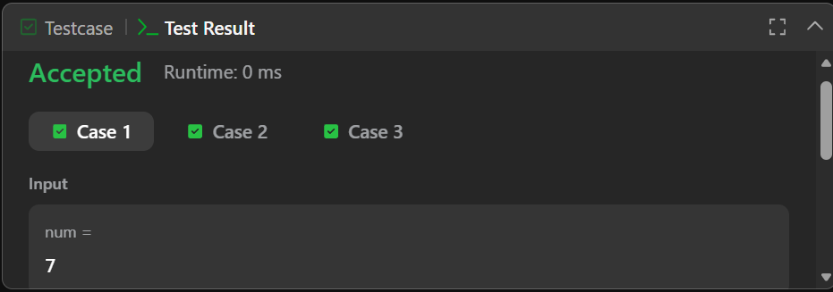

Q5. 9 — Palindrome Number
#Code
class Solution {
public:
bool isPalindrome(int x) {
int original = x;
int reverse = 0;
int digit;
if (x < 0) {
return false;
}
while (x > 0) {
digit = x % 10;
reverse = reverse * 10 + digit;
x = x / 10;
}
if (original == reverse) {
return true;
}
else {
return false;
}
}};
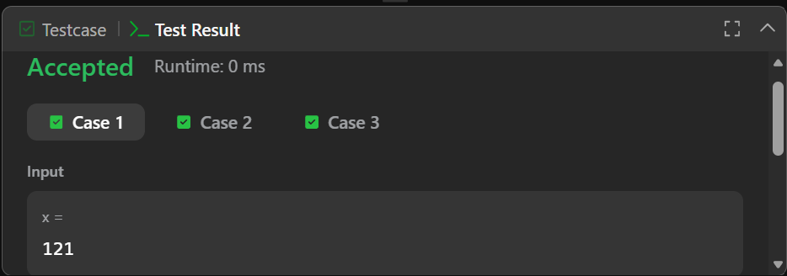

Q6. 7 — Reverse Integer
#Code
class Solution {
public:
int reverse(int x) {
int rev = 0;
int digit;
while (x != 0) {
digit = x % 10;
if (rev > INT_MAX / 10 || rev < INT_MIN / 10) {
return 0;
}
rev = rev * 10 + digit;
x = x / 10;
}
return rev;
}
};
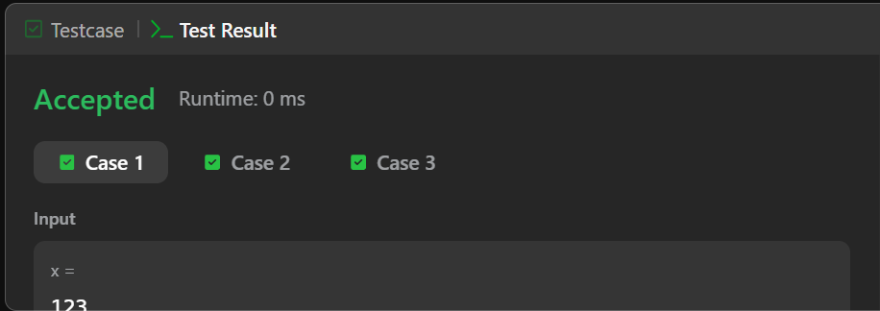

#Module 5

Q1. 231 — Power of Two
#CODE
class Solution {
public:
bool isPowerOfTwo(int n) {
if (n <= 0) {
return false;
}
while (n % 2 == 0) {
n = n / 2;
}
if (n == 1) {
return true;
}
else {
return false;
}
}
};
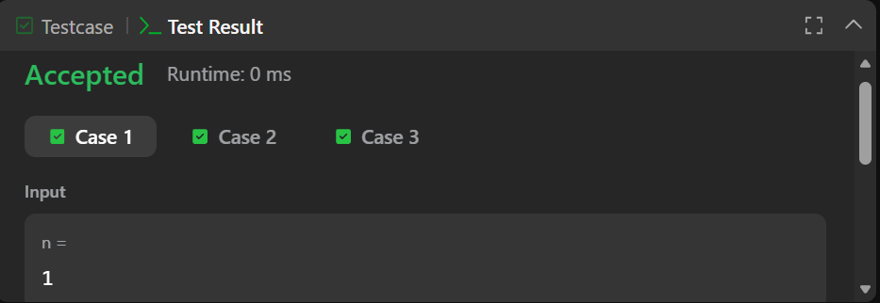

Q2. 326 — Power of Three
# CODE
class Solution {
public:
bool isPowerOfThree(int n) {
if (n <= 0) {
return false;
}
while (n % 3 == 0) {
n = n / 3;
}
if (n == 1) {
return true;
}
else {
return false;
}
}
};
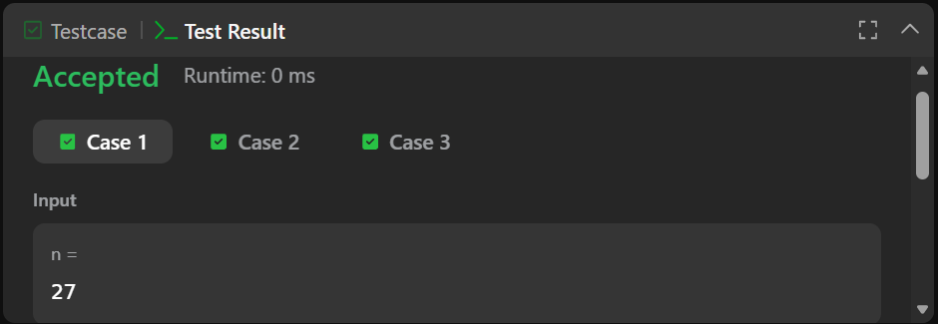

Q3. Factorial!
#CODE
#include <stdio.h>
int main() {
int num;
long long fact = 1;
scanf("%d", &num);
for (int i = 1; i <= num; i++) {
fact = fact * i;
}
printf("%lld\n", fact);
return 0;
}
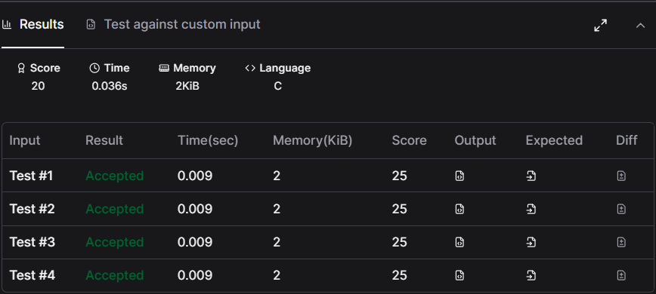

Q4. Count Divisors
#CODE
#include <stdio.h>

int main() {
int l, r, k;
int count = 0;
scanf("%d %d %d", &l, &r, &k);
for (int i = l; i <= r; i++) {
if (i % k == 0) {
count++;
}
}
printf("%d\n", count);
return 0;
}
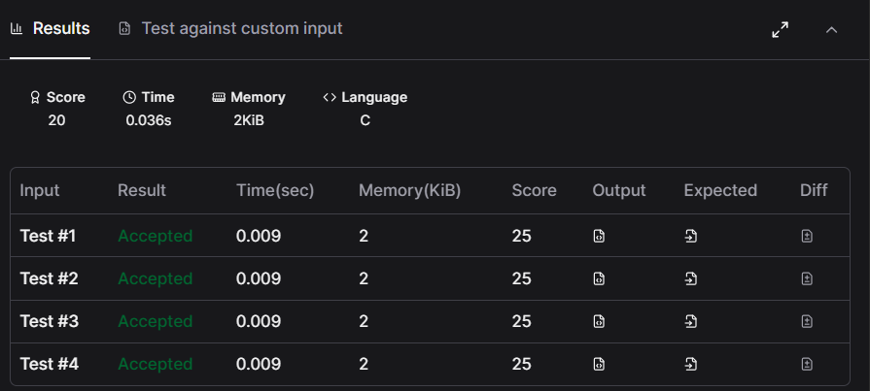

Q5. Prime Numbers
#CODE
#include <stdio.h>
int main() {
int num;
int count = 0;
scanf("%d", &num);
for (int i = 1; i <= num; i++) {
if (num % i == 0) {
count++;
}
}
if (count == 2) {
printf("1\n");
}
else {
printf("0\n");
}
return 0;
}
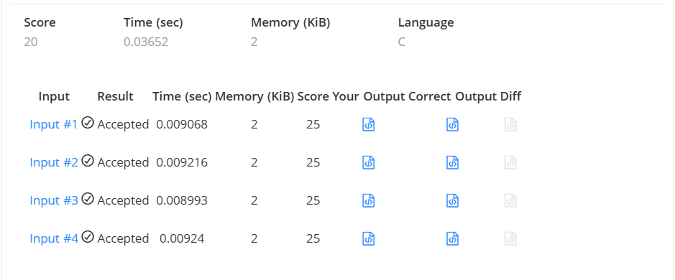

Q6. 507 — Perfect Number
#CODE
class Solution {
public:
bool checkPerfectNumber(int num) {
if (num <= 1) {
return false;
}
int sum = 1;
for (int i = 2; i <= num / 2; i++) {
if (num % i == 0) {
sum = sum + i;
}
}
if (sum == num) {
return true;
}
else {
return false;
}
}
};
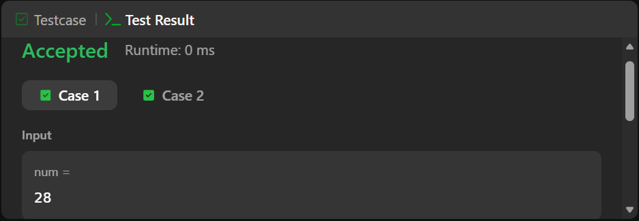

#MODULE 6

Q1. Staircase
#CODE
void staircase(int n) {
for (int i = 1; i <= n; i++) {
for (int j = 1; j <= n - i; j++) {
printf(" ");
}
for (int k = 1; k <= i; k++) {
printf("#");
}
printf("\n");}}
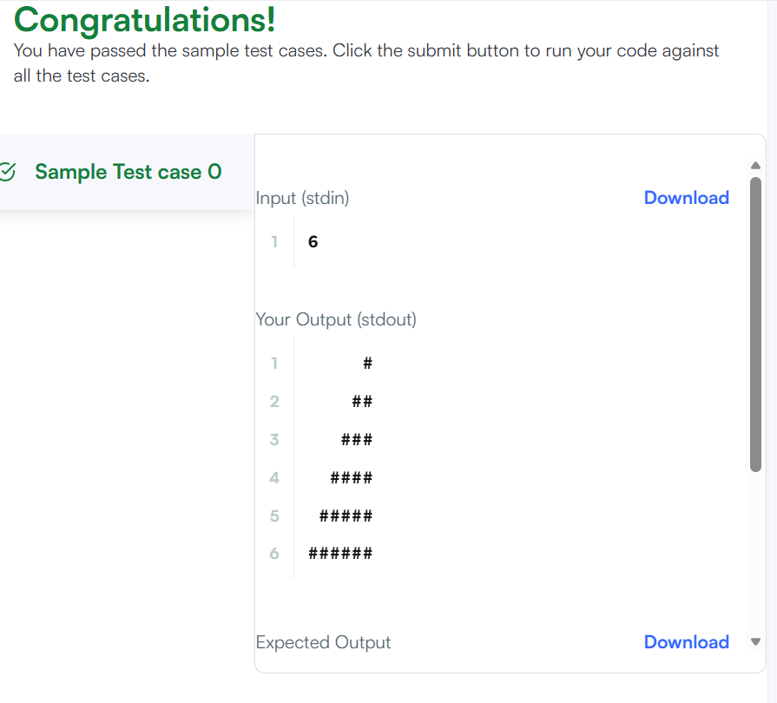

Q2.Printing Pattern Using Loops
#CODE
#include <stdio.h>
#include <string.h>
#include <math.h>
#include <stdlib.h>

int main()
{
int n;
scanf("%d", &n);

for (int i = 0; i < 2 * n - 1; i++)
{
for (int j = 0; j < 2 * n - 1; j++)
{
int a = i;
int b = j;

if (a > 2 * n - 2 - i)
a = 2 * n - 2 - i;

if (b > 2 * n - 2 - j)
b = 2 * n - 2 - j;

int min = a;

if (b < min)
min = b;

printf("%d ", n - min);
}

printf("\n");
}

return 0;
}


